Government College of Engineering, Nagpur Hosts Its First-Ever Marathon in SFOORTI-2025

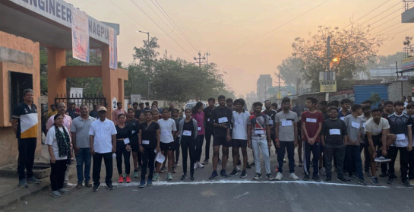
GCOEN’s annual sprots event SFOORTI-25 was recently inaugurated at the hands of Indian P. D Cricket team player Mr. Lokesh Margade. During his speech, Lokesh shared insights from his successful journey in cricket, inspiring students with his dedication and perseverance. He emphasized the importance of sports in shaping discipline and teamwork, encouraging participants to give their best in the upcoming competitions.
During Sfoorti, GCoE Nagpur, witnessed a historic event as it hosted its first- ever marathon, a 3 km race organized entirely by the students. The initiative, conceived and executed by the students, aimed to promote fitness and unity among participants.
The marathon saw enthusiastic participation from students, faculty members, and even the college principal, making it a truly inclusive event. Several students secured top positions and won exciting prizes for their performance. From Boys Dipak varma, D hiraj kambale, Sagar pardhi and from Girls Arya kurlkar, Kavi ri karpe, Reshal bhati won first, second & Third positions respectively.
Ensuring the safety and well-being of all participants, Swami Vivekanand Hospital provided ambulance services and necessary medical support. Local police also played a crucial role in managing security and maintaining order throughout the event.
The success of the marathon was further boosted by generous sponsorships from various organizations, highlighting the strong community support for student-led initiatives. The event marked a significant milestone for the college, setting the stage for more such activities in the future.
With overwhelming participation and appreciation, the first-ever marathon at Government College of Engineering, Nagpur, proved to be a grand success, inspiring students to continue organizing impactful events. This event was very well appreciated by Principal Dr. R. P. Borkar, Dean SW Dr. K. G. Asutkar, Faculty coordinator Prof. S. R. Wagh, Head Civil Engg Dr. S. N.Khante, ETC Head Dr. D. S. Chaudhari & Prof. S. P. Jolhe for students untiring efforts.


winners :- Boys 1. Dipak varma
2. D hiraj kambale
3. Sagar pardhi
Girls 1. Arya kurlkar
2. Kavi ri karpe
3. Reshal bhati

Prize :- 1st Prize 2.5k
2nd Prize 1.5k
3rd Prize 1k

Our Sponsors :-

Sfoorti Inauguration

After the marathon, the inauguration of Sfoorti, our annual sports event, took place. The chief guest for the event was professional cricketer, Indian PD cricket team player and Para Olympic player, Lokesh Marrghade. The inauguration ceremony began at 10:00 a.m. on Saturday,
February 1, 2025, at the sports ground of Government College of Engineering, Nagpur.
During his speech, Lokesh shared insights from his successful journey in cricket, inspiring
students with his dedication and perseverance. He emphasized the importance of sports in shaping discipline and teamwork, encouraging participants to give their best in the upcoming competitions.
Following the inauguration, college students enthusiastically participated in various matches, showcasing their talent and sportsmanship. The atmosphere was electric as the audience
cheered for their favorite teams, making the opening day of Sfoorti a memorable and energetic start to the much-awaited sports event.
With this exciting beginning, Sfoorti promises to be a thrilling event, bringing together students to compete, collaborate, and celebrate the spirit of sportsmanship.

Photographs :-

