SUCCESFUL INNAUGRATION OF SPORTS WEEK ‘SFOORTI’ 2022 OF GCOEN

Government Engineering College, Nagpur is continuously striving for the overall development of the college students. On 15th March 2022 Ranji Trophy Player renowned former Indian Cricket Team Player Shri. Prashant Vaidya, the Principal of the Institute Dr. R.P.Borkar inaugurated "Sfoorti 2022" . This year, the Sfoorti was scheduled from 16 to 21 March. Sfoorti gets the multitude of participants in 11+ sports competitions. This year the sports included Cricket, Football, Kabaddi, Kho-Kho, Volleyball, Tug of War, Relay, Badminton, Chess, Carrom,Table-Tennis. The inauguration was conducted with great enthusiasm and spirits in the presence of teaching staff, non-teaching staff and students. The program started with the lighting of the torch by the chief guest. During the program the NCC team, student sports coordinators and also the students participating in various sports conducted a disciplined march. In the inauguration the principal of the institute emphasized the importance of versatile personality in modern as well as competitive era. Also the chief guest of the program Mr. Prashant Vaidya in his orientation speech gave detailed information about the mental and physical benefits of various sports to the students. The vote of thanks for the program was done by the student representative of the college. The program was moderated by Sunil Mane, Sport Secretary of Student Welfare Committee and Onkar Khumbhar, President to make the program successful. Dr. K.M.Tajne, Dean Student Welfare Cell, Dr.Tekade, Technical coordinator, Dr. C. P. Kalambe,Head Science & Humanities, Prof.R.M.Sahare Cultural Coordinator, Prof. S. R Wagh Sports Coordinator, student sports coordinator and his team contributed to the success of the program. The program mainly benefited from the presence of department heads, teaching and non-teaching staff of the college.
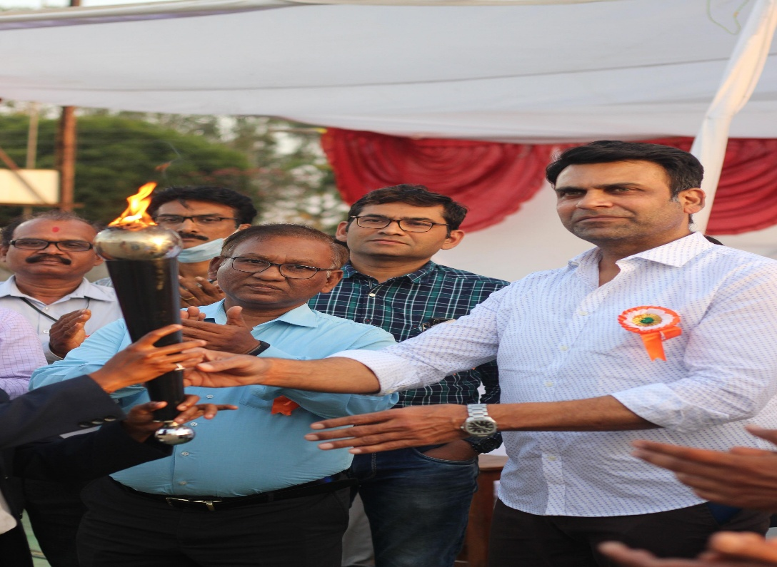
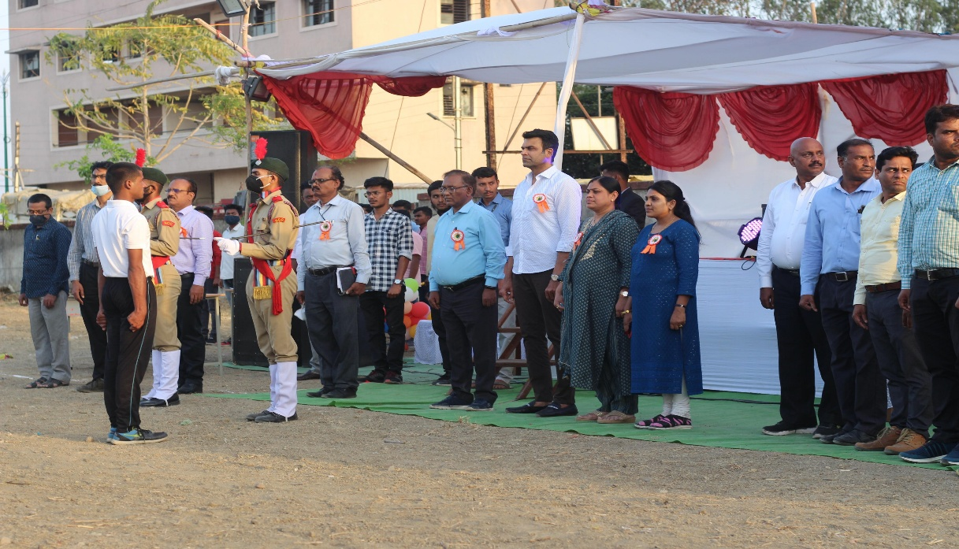

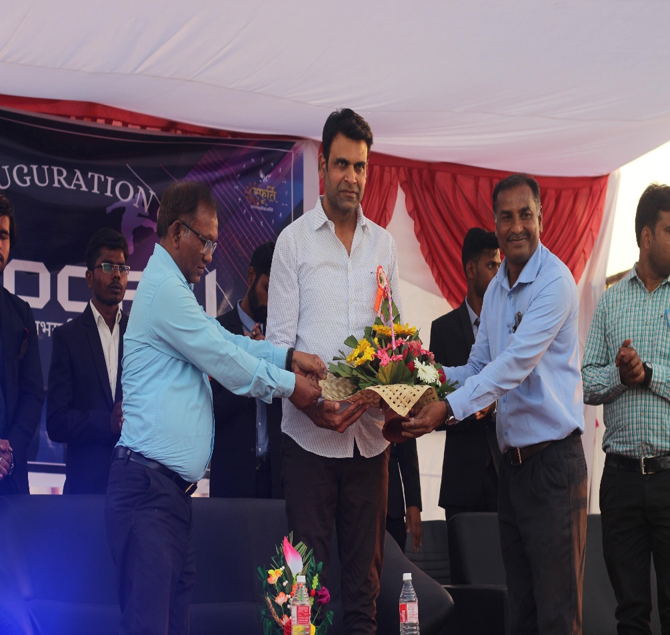

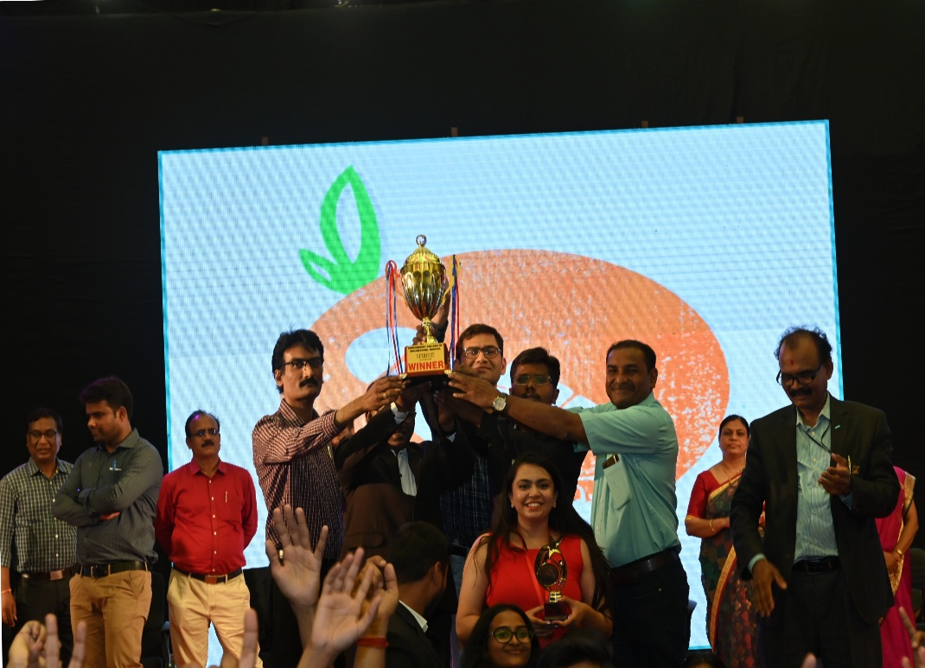

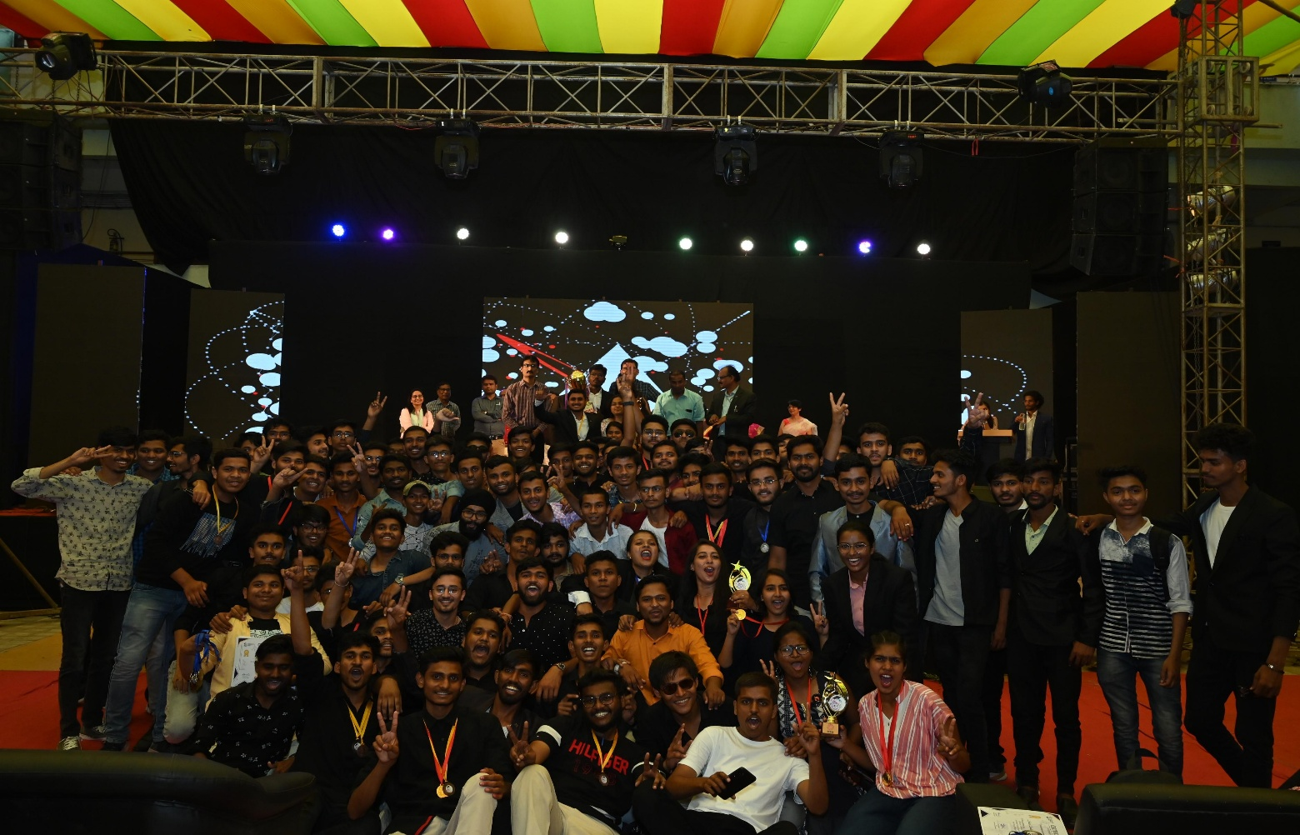

Trophy of 'SFOORTI 2K22’ goes to
Mechanical Branch

