"The grand cultural festival 'Oranz-24' was organized at the renowned Government engineering college, Nagpur. Noted Marathi stand-up comedian, poet, and ghazal writer, Mr. Kishor Bali, graced the inaugural ceremony. Following up the sequence of the event, Mr. Kishor Bali also inaugurated the 'Kala Sparsh', the art exhibition where students displayed their artworks which were appreciated by the guest. The lighting of the lamp was done by Principal Dr. R. P. Borkar, Dean of Student Welfare Cell Dr. Kiran Tajne, Cultural Coordinator Dr. C. P. Kalambe and Prof. Rajni Sahare and committee members were also present. The program commenced with various folks dance performances and welcome dance. Subsequently, students presented dance and drama performances. The 'Mehfil-e-Jugalbandi' segment was also thoroughly enjoyed by the audience. Lastly, melodious student voices left a lasting impact on the audience. The program of the second day of Oranz-24 started with a session by 'GCOEN ki Adalat' . During this, professors were asked questions in a unique manner. Later, there were demonstrations of dance and drama skills. Finally, the winners of 'Oranz-24' and 'Sfoorti-24' competitions were announced, and Principal Dr. R. P. Borkar and other college professors felicitated them. The event was hosted by Jay Bhale. Yash Bhagat, President of Student Welfare Committee, presented the report of the Student Welfare Cell, and Manjeet Naik, Cultural Secretary of Student Welfare Committee, expressed gratitude by proposing the vote of thanks. The festival concluded with an energetic DJ night. All the students of the Oranz-24 committee worked hard for the success of the event."

Day 1: inaugural ceremony
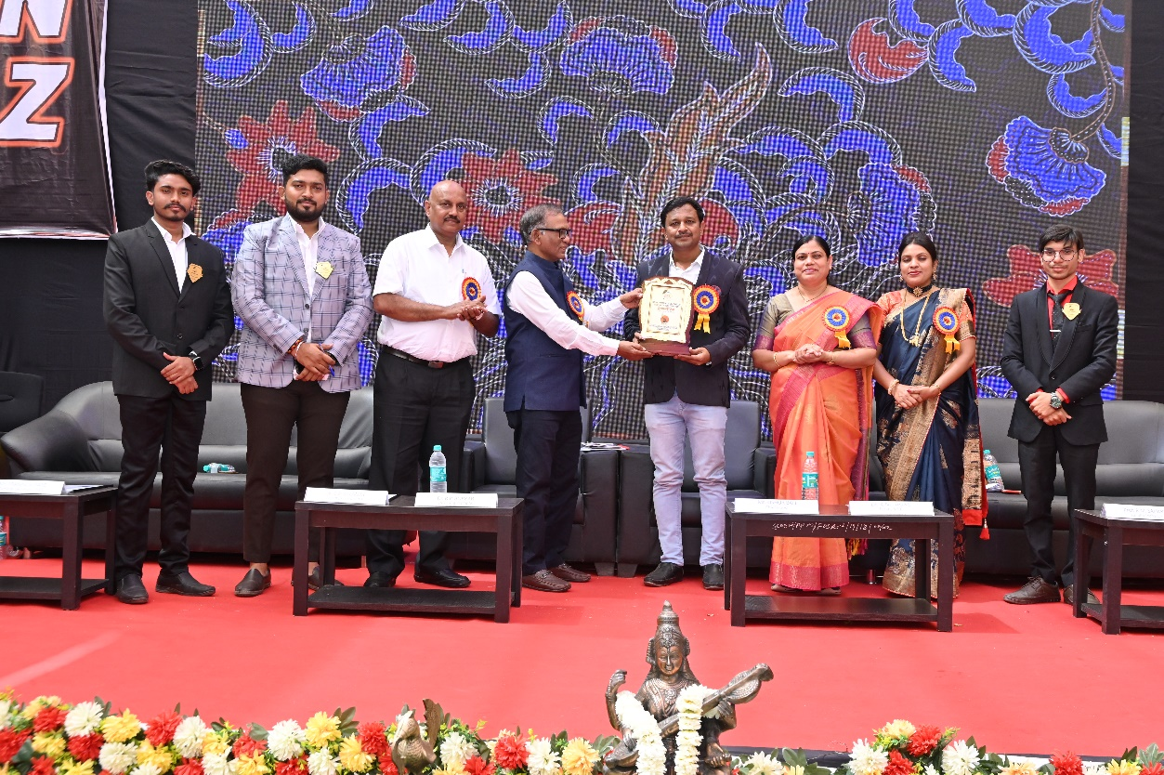
welcome dance 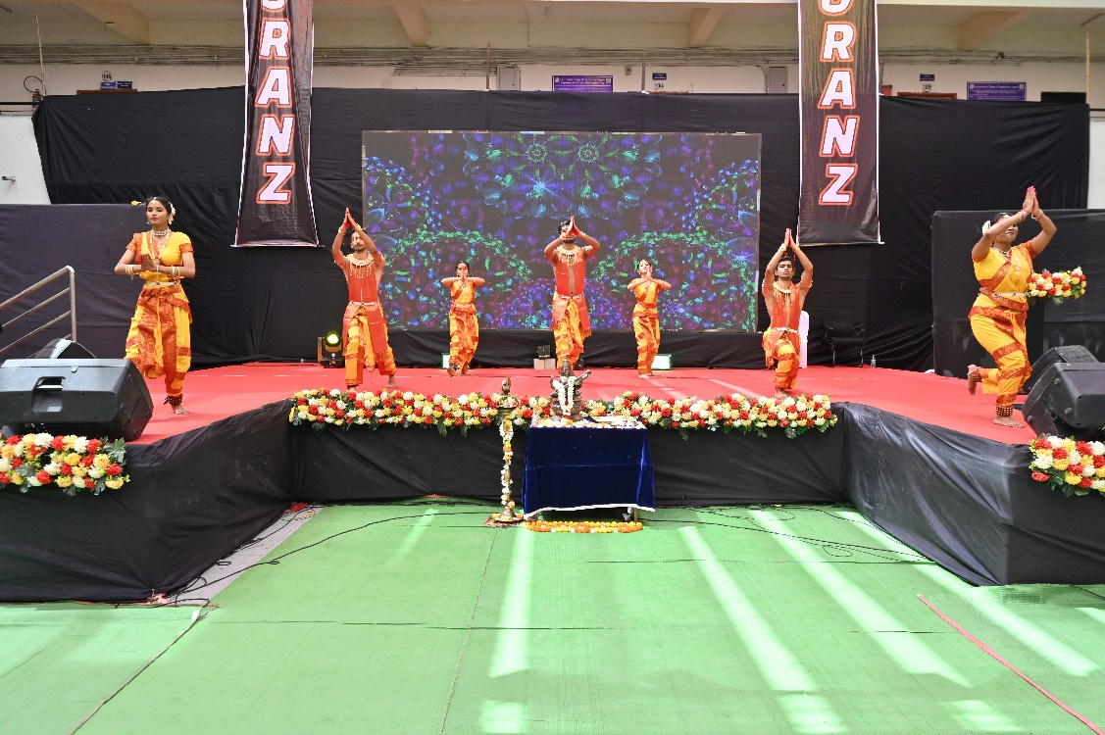

'Kala Sparsh'
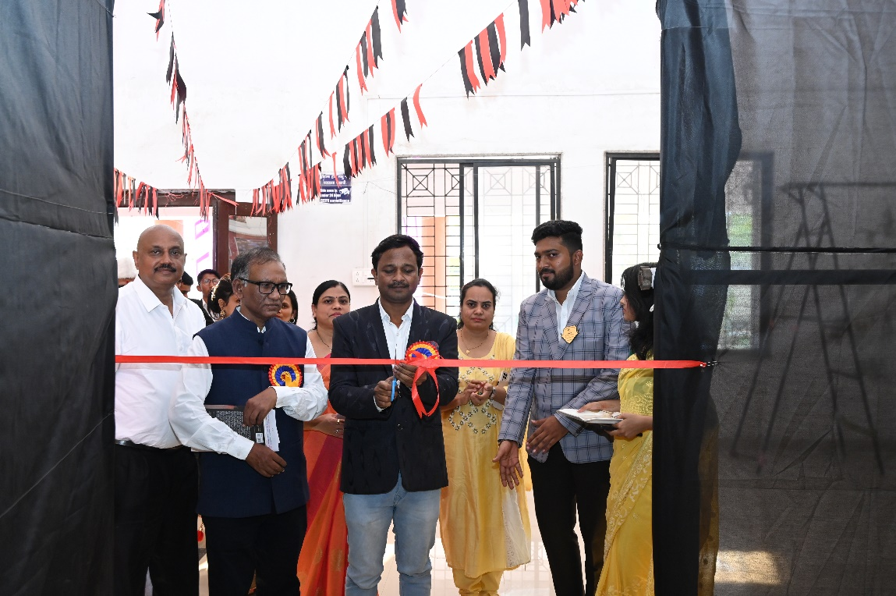

Day 2 :- prize distribution
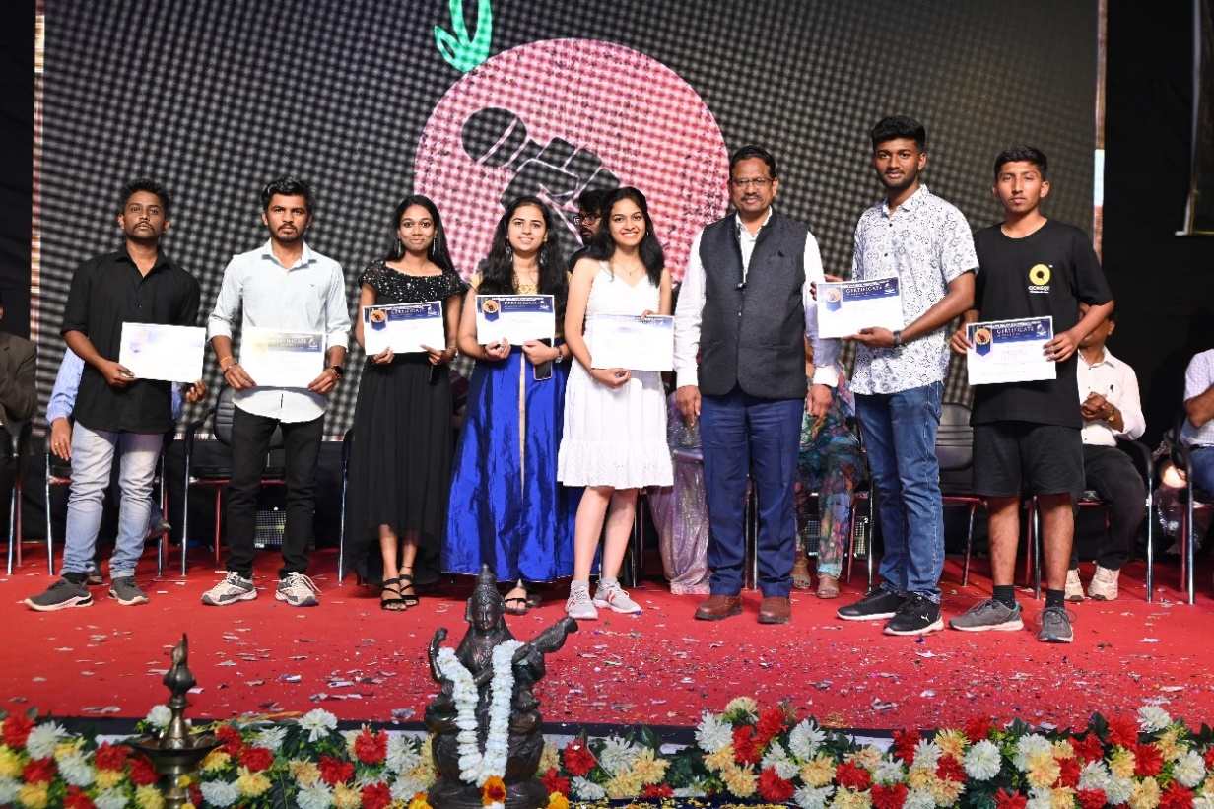

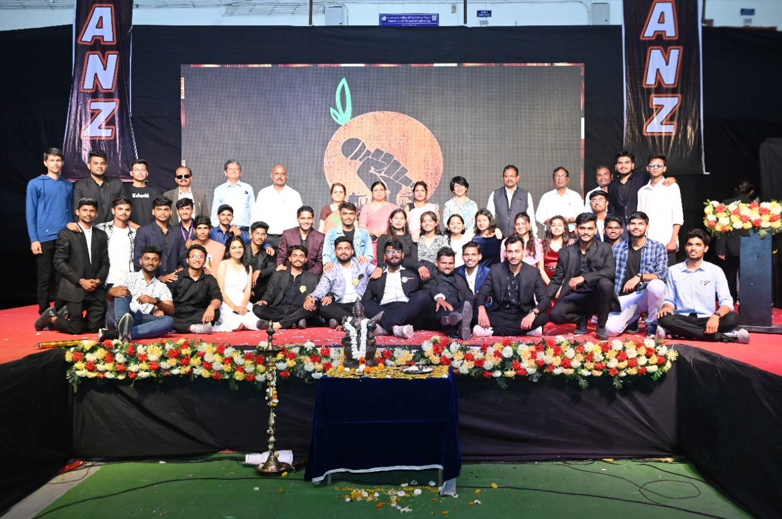

Fashion show
