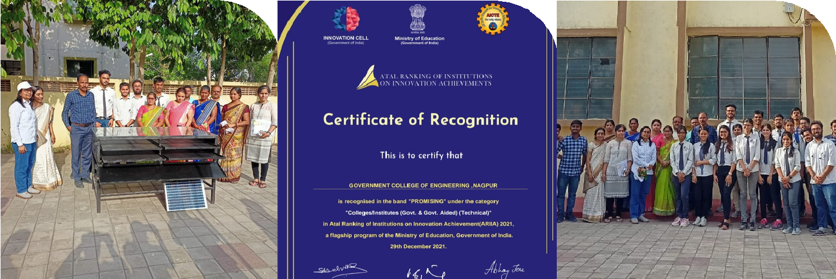

ARIIA
ATAL RANKING OF INSTITUTIONS
OF INNOVATION ACHIEVMENTS

Atal Ranking of Institutions on Innovation
Achievements (ARIIA) is an initiative of Ministry of Education (MoE), Govt. of India to
systematically rank all major higher
educational institutions and universities in India on indicators related to “Innovation and
Entrepreneurship Development” amongst students and faculties.

