DEPARTMENT OF MECHANICAL ENGINEERING

INDUSTRIAL VISIT

SESSION:2022_23

VISIT TO KORADI THERMAL POWER STATION
DATE:12/10/2022
THIRD YEAR MECHANICAL ENGINEERING STUDENTS

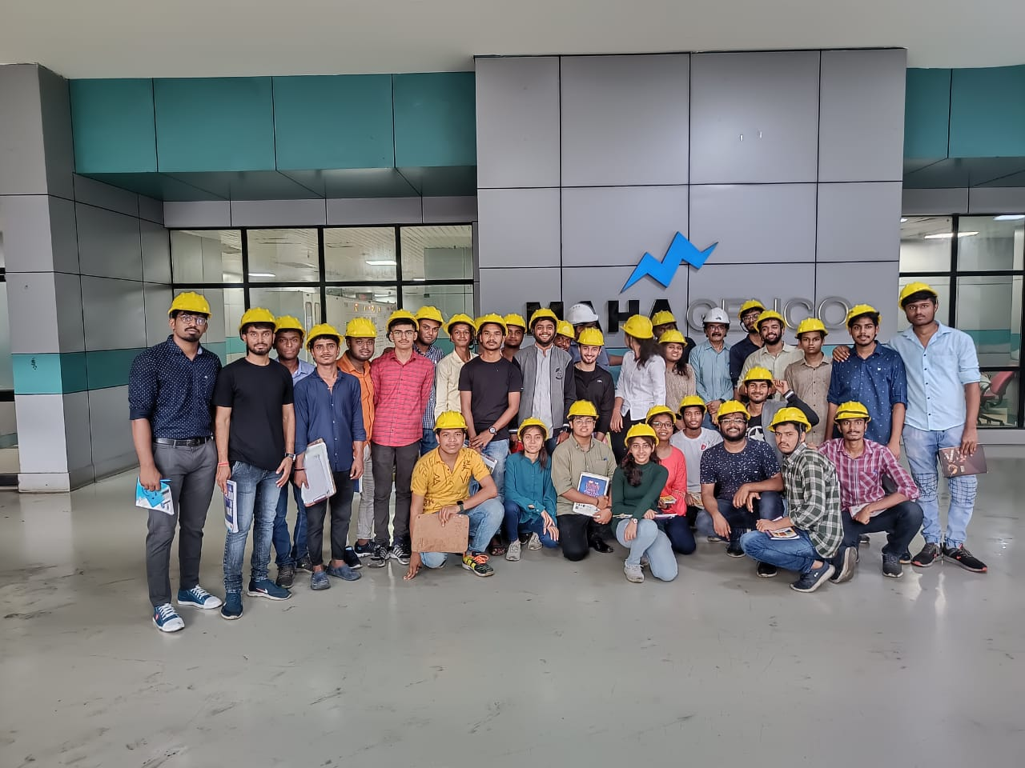
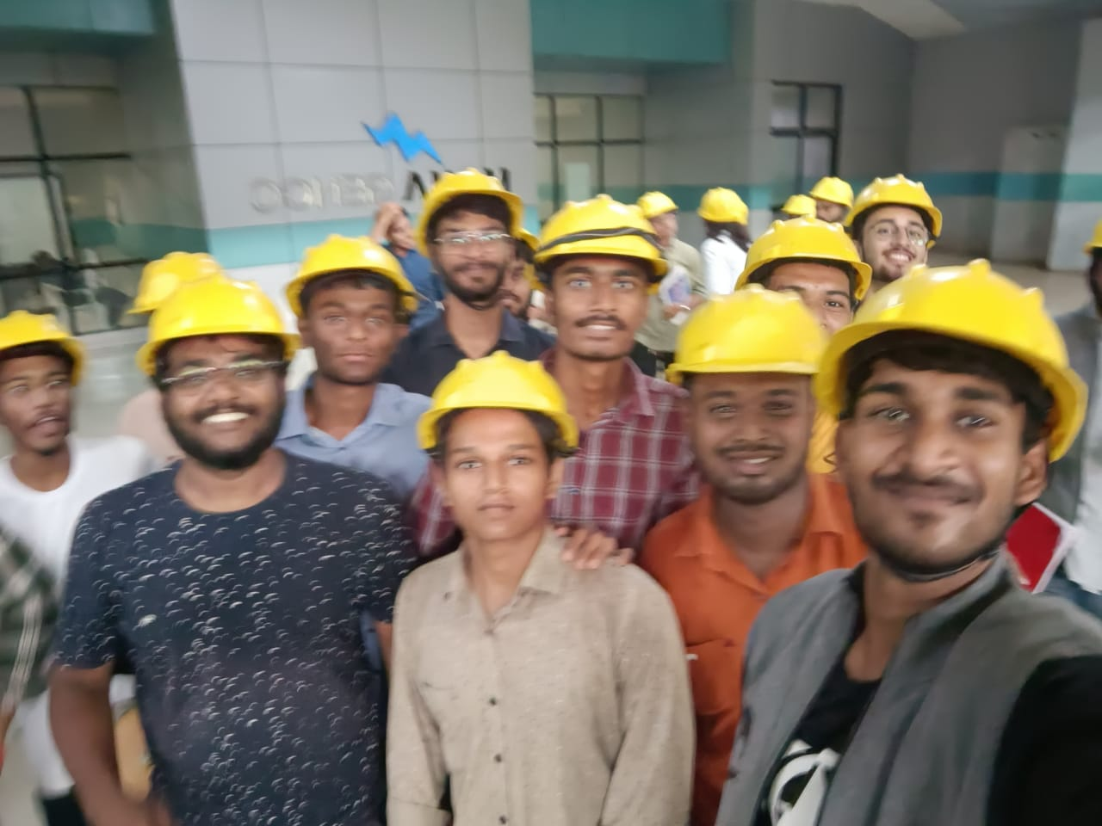
VISIT TO INDUSTRIAL TRAINING INSTITUTE
DATE:18/10/2022 & 19/10/2022
THIRD YEAR & FINAL YEAR MECHANICAL ENGINEERING STUDENTS

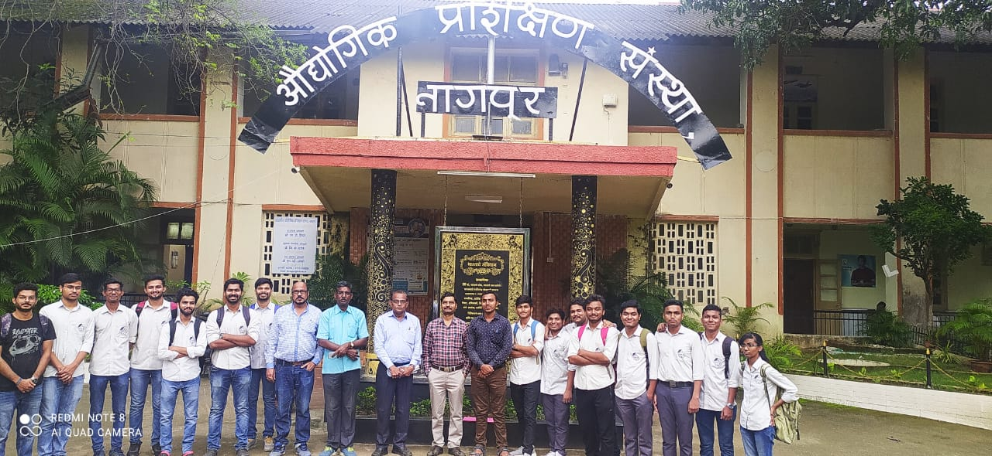

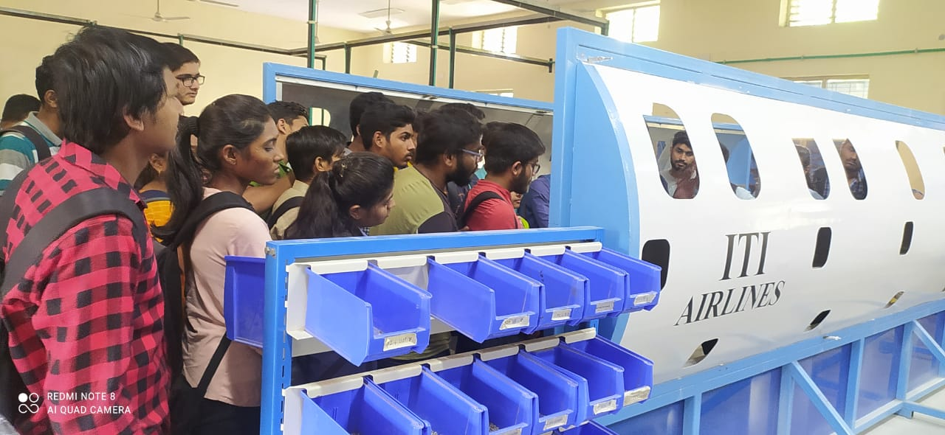

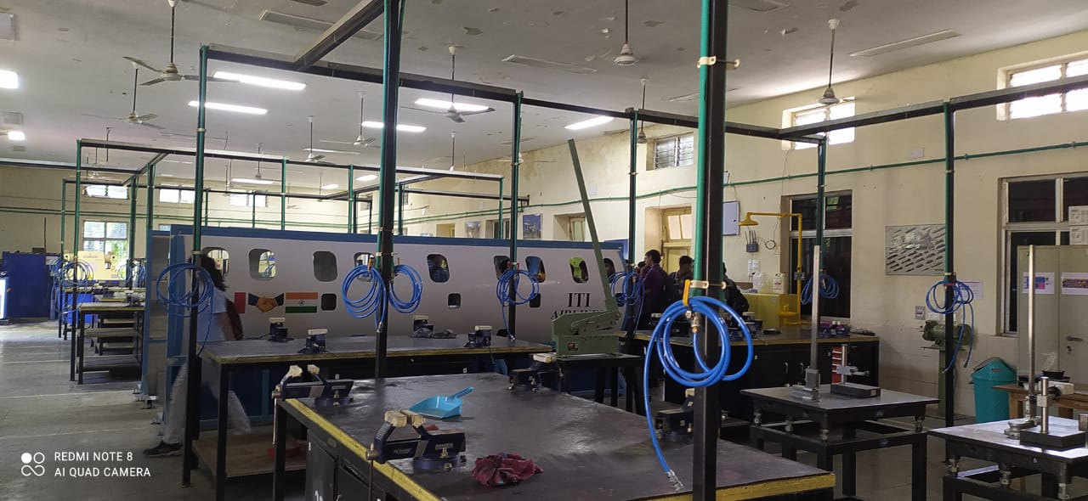

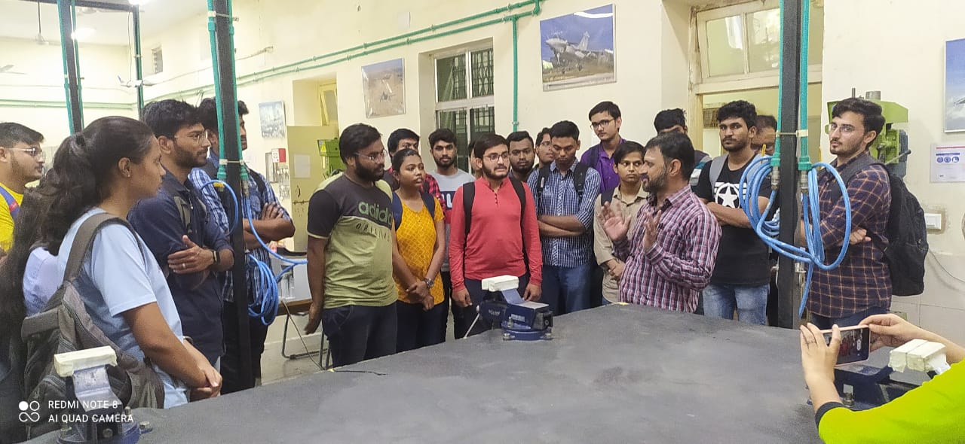

VISIT TO SHILPA STEEL PLANT
BUTI BORI,NAGPUR
FINAL YEAR MECHANICAL ENGINEERING STUDENTS

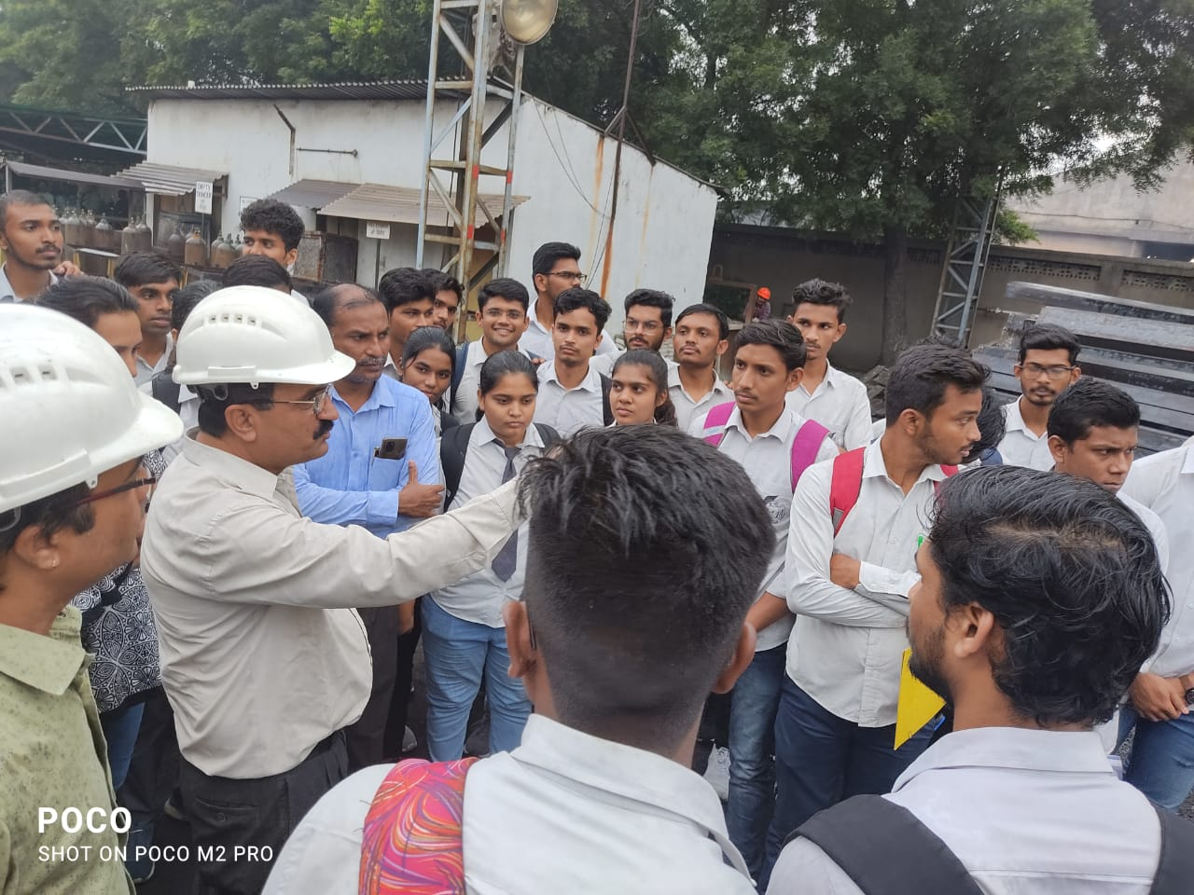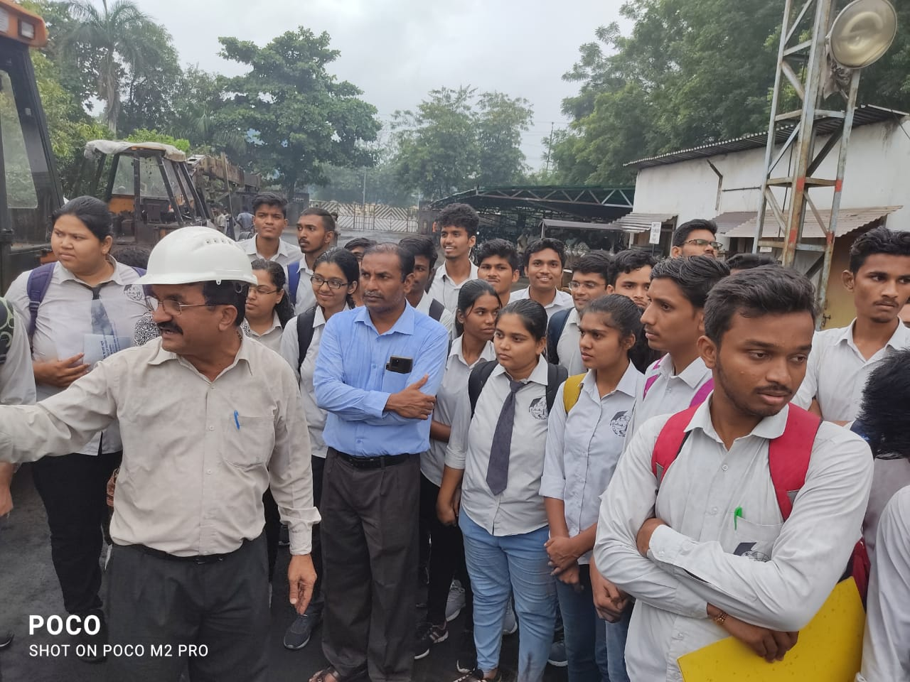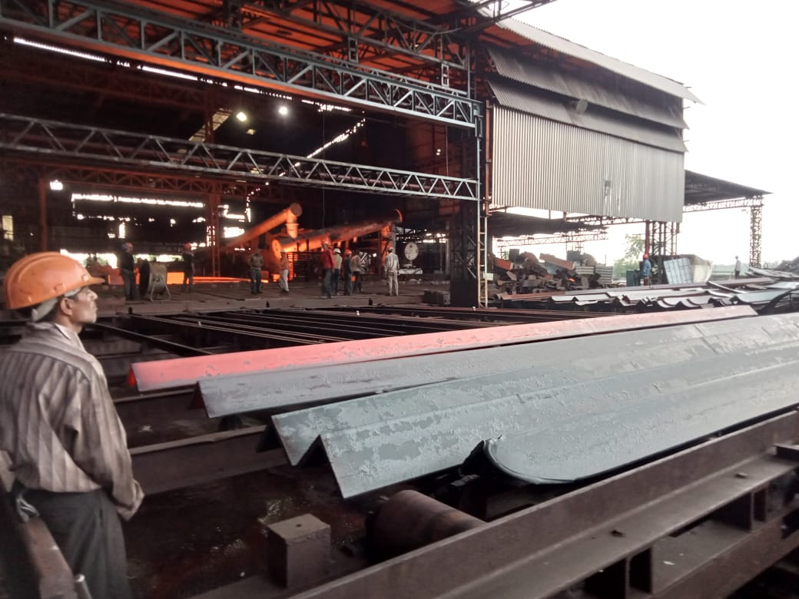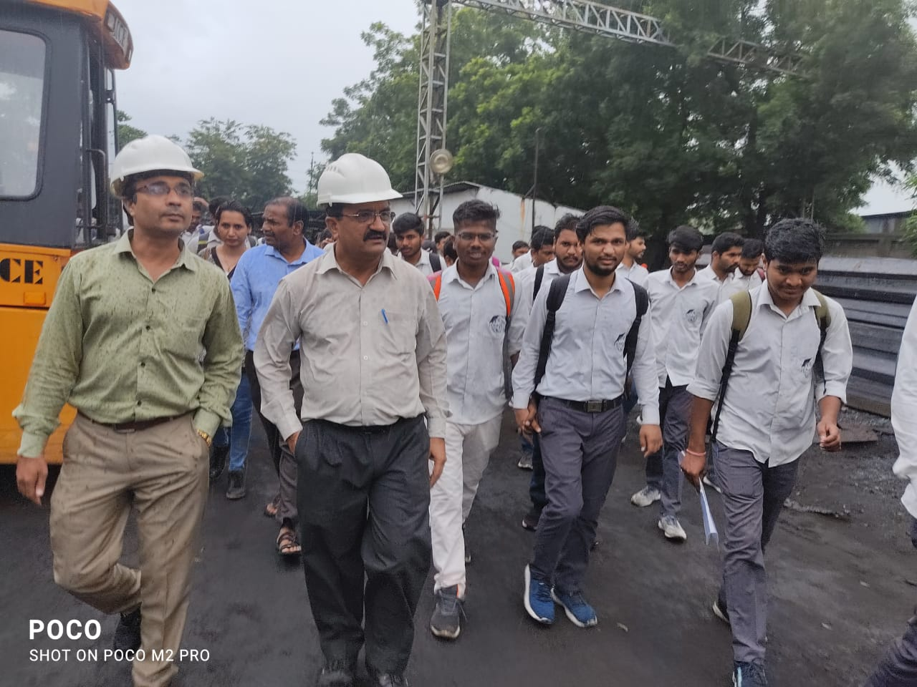

DEPARTMENT OF MECHANICAL ENGINEERING

INDUSTRIAL VISIT

SESSION:2021_22

VISIT TO SHIVAM FOOD PRODUCTS & MONIKA ICE CUBES NAGPUR
FINAL YEAR MECHANICAL ENGINEERING STUDENTS

