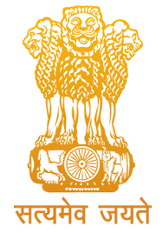


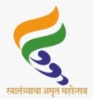
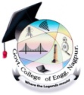
Government of Mahrashtra
Government College of Engineering, Nagpur
Sector-27, Mihan Rehabilitation Area,New
Khaapri- 441108¼Maharashtra State½
(NAAC Accredited B⁺⁺ Grade 2.93)
“To be an Institution of National Repute Creating Globally Competent Technocrats to Serve the Society”
दुरध्वनीक्र. 07103-295226(P), 295220(O) Website:- www.gcoen.ac.in
E-mail: principal.gcoenagpur@dtemaharashtra.gov.in - office.gcoenagpur@dtemaharashtra.gov.in

Name of Institute: GOVERNMENT COLLEGE OF ENGINEERING, NAGPUR

Event Name and Date:
International Conference On Research & Innovative Perspectives in Engineering (ICRIPE-2025) 23rd-24th January 2025 In collaboration with Bureau of Indian Standard

Purpose: [Event Name & Objective] International Conference on Research & Innovation Perspectives in Engineering “ICRIPE-2025”. It is multidisciplinary conference covering range of topics from Civil, Mechanical, Electrical, Computer Science & Engineering, Electronics & Telecommunication, and Indian Standards.

The conference aims to raise awareness about the latest trends in Research & Innovative Perspectives in Engineering. It will bring together major organizations and institutions actively involved in research and development activities in engineering and science from across the globe. It is the premier platform for presentation of state of art advances and research in various engineering fields. It will provide an opportunity to the participants to interact and establish network with researchers and industry experts.

- Event Impact Metrics

The following metrics highlight the success and impact of the event:

Total Number of Participants: 177 Participants registered for conference

Track | Total papers Received | Accepted | Outside Institute | Outside State | Within GCOEN | Total | Presented | Best Paper ID No.
Civil | 54 | 46 | 27 | 2 | 9 | 38 | 32 | 219
CSE | 87 | 31 | 14 | 2 | 5 | 21 | 21 | 201
EE | 30 | 28 | 12 | 0 | 14 | 26 | 24 | 224
ETC | 34 | 33 | 13 | 0 | 1 | 14 | 14 | 181
Mech | 32 | 32 | 21 | 0 | 8 | 29 | 26 | 245
Total | 237 | 170 | 87 | 4 | 37 | 128 | 117

Notable Guests: [List of key speakers, panelists, chief guests, etc. from BIS and other notable guests who attended]

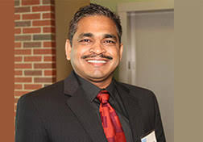 | Dr. Sudarshan Kurwadkar  PhD in Environmental Engg  Professor of Civil and Environmental Engineering  California State University, Fullerton(USA)  Title of keynote:State of the Environment: Innovative Solutions for Sustainable Water and Wastewater Management in Urban Areas  In his addressed he highlighted the problems of water scarcity in USA and India too. He stressed upon the technology to be adopted to address the water scarcity occurring in global areas.
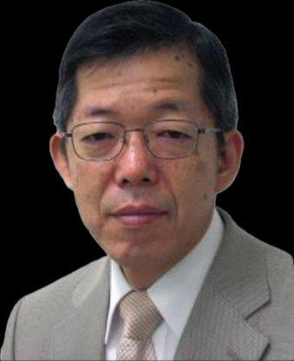 | Dr. Yasuyuki Nishida  Qualification: Dr. of Engr.  Affiliation: Technical Consultant of Headspring Inc. (JAPAN)  Specialization:- Power-Electronica, especially several types of utility interfaces and. PE education.  Keynote Topic: A Modern Japanese Power-Electronics Education Tool by means of RAPID.  He deliberated upon the contact less charging of vehicles and innovation in power electronics.
Day 2- 24th Jan 2025
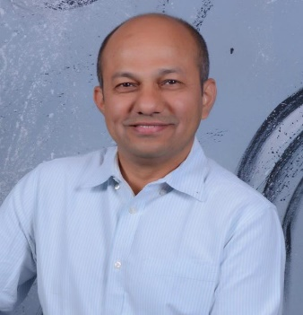 | Dr.Tarendra Lakhankar  PhD in Civil Engineering (Water Resources) from The Graduate Center of the City University of New York (USA)  Director, Education and Training Pillar, CUNY CREST InstituteNew York  Keynote Topic: Satellite Remote Sensing Applications in Engineering and Educational Opportunities in USA  He gave an insight to all possible Remote sensing applications, challenges paving way for possible Research in the field
 | Sandesh Sudhakar Gokanwar  Post- Scientist D/Joint Director  Organization- Bureau of Indian Standard(INDIA)  Keynote Topic: Bureau of Indian Standards – Importance & Opportunities  He focused on the Basic of Standards and its importance and also briefed the participants about initiatives of BIS.

Report on Poster Presentation

Institute Name: Government College of Engineering, Nagpur
Event Name & Date: Poster Presentation

- Poster Presentation for UG students
As part of International Conference (ICRIPE) to be organized at Government College of Engineering, Nagpur on 22-23 January 2025, the Poster Presentation and Model/Project Presentation foe students of Government College of Engineering, Nagpur was organized on 23/01/2025. The purpose of this activity was to encourage students to exhibit research attitude. The event was organized in collaboration with Bureau of Indian Standards. 62 undergraduate students of Government College of Engineering, Nagpur from various tracks such as Mechanical Engineering, Civil Engineering, Computer Science Engineering, Electrical Engineering and Electronics and Telecommunication Engineering participated in the event. They exhibited their innovative ideas and concepts through these posters to the audience.

- Event Impact Metrics

The following metrics highlight the success and impact of the event:

- Total Number of Participants: 62
- Categories of Attendees:Students
- Notable Guests:
The event was inaugurated at the hands of Chief Guest Ms.Mizuki Sato, Director, Maruhachi Tent Co. Ltd, Japan. Guests for the event included Mr. Noboru Yamada, CEO, Hilltop Marketing Service, Japan; Mr. Towa Mitsuhara, Intern from Maruhachi Tent Co. Ltd, Japan; Mr.ShashankWadekar, Vice President at Hilltop Marketing, Japan.

The prominent judges for the event were Dr.LaxmanKumarwad, Regional Director, IGNOU Regional Centre, Nagpur, Dr. M.B. Deokate, Principal, Priyadarshini Polytechnic, Nagpur, and Mr.SandeshGokanwar, Scientist/Joint Director, Bureau of Indian Standards, Nagpur.

- Activities organized:
The participants exhibited posters on emerging technical areas such as electrical vehicles, artificial intelligence, green energy, latest in structural engineering, etc.

- Achievements & Outcomes:

The efforts of the participants were appreciated and recognized by awarding ‘Best Poster Award’ in the competition. Eleven cash awards to the tune of ₹25,000 were awarded to the participants for their exhibition of ideas/concepts through posters.

Best Poster Award(Overall),Poster awards(Department wise) and Prizes for Poster competition under ICRIPE 2025
SN | Name of Branch/Department | Names of students/participants | Name of poster | Type of Awards | Cash Award
1 | Mechanical Engineering | Mohammad Imad Mohammad Maroof Sheikh,  Aryan RajuNagpure | Design And Development of Smart Multipurpose Agricultural Machine: (Integrating IOT-driven Pesticide Spraying and Micro Tilling for Multiple Crops and Trees) | Best Poster (Overall) | Rs.5000/-
2 | Mechanical Engineering | AdityaKyawal,  Snehal Joshi | Design And Fabrication of Prototype of Tracker Based Solar Water Pumping System | Rank 1-Poster (Mech. Engg.) | Rs.2500/-
3 | Mechanical Engineering | ShubhamDilipDeshmukh,,  DevkumarNitinYerme | Development of Cleaning system for Broaching Machine | Rank 2-Poster (Mech. Engg.) | Rs.1500/-
4 | Civil Engineering | YashLanjewar,  Shashank Mishra | Hot liquids,  Hidden Hazards: Investigating the leaching of chemicals from paper cup | Rank 1 Poster (Civil Engg.) | Rs.2500/-
5 | Civil Engineering | RoshanPiprewar,  UjjwalKhaire | Relief Stations in Smart Cities | Rank 2 Poster (Civil Engg.) | Rs.1500/-
6 | Electronics and Telecommunication | NiharikaNagpurkar,  PrashanshaTambe | Health Monitoring Devices | Rank 1 Poster (Electronics and Tele.) | Rs.2500/-
7 | Electronics and Telecommunication | Ravi Bharti,  SagarPaithankar | Smart Cattle Health Monitoring System | Rank 2 Poster (Electronics and Tele.) | Rs.1500/-
8 | Electrical Engineering | SakshiKawade | Design Of Electrical Bicycle For Sustainable Urban Mobility | Rank 1 Poster (Electrical Engg.) | Rs.2500/-
9 | Electrical Engineering | Prathamesh Nakade,  Sushant Gupta | IOT based smart vehicle monitering system | Rank 2 Poster (Electrical Engg) | Rs.1500/-
10 | Computer Science Engineering | EshaChandrashekharRangari | NavGuide: Indoor Navigation for visually Impaired | Rank 1 Poster (Comp. SciEngg.) | Rs.2500/-
11 | Computer Science Engineering | DevanshParapalli ,  YashasviThool | AI powered knowledge organizer for diverse data formats | Rank 2 Poster (Comp. SciEngg.) | Rs.1500/-
Based on the evaluation by respective external judges for poster competition, the details of Best Poster Award (Overall), Poster awards (Department wise) and Prizes for Poster competition under ICRIPE 2025 are as follows:

3.Supporting Documents(Attached as Annexures)

- Photographs of the Event

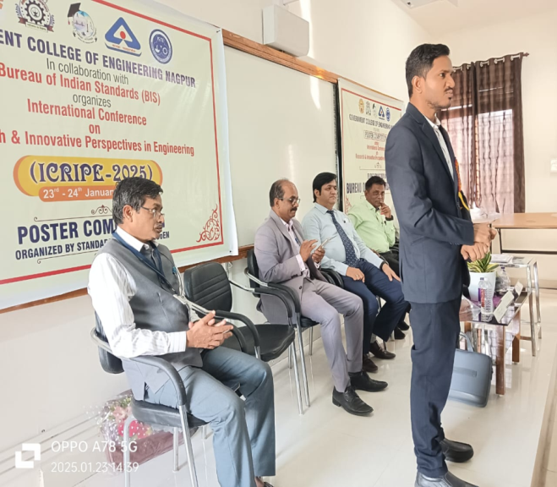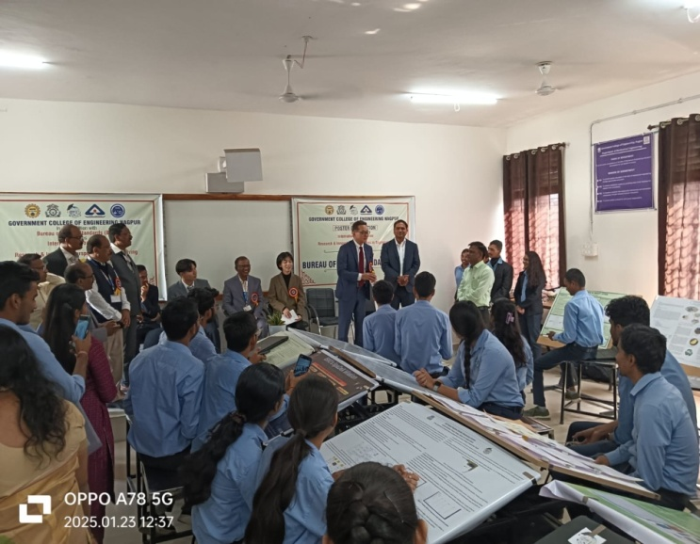

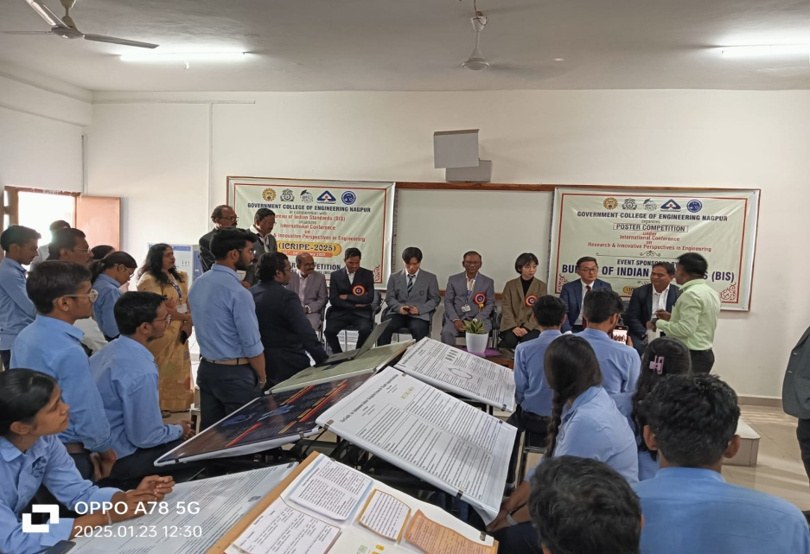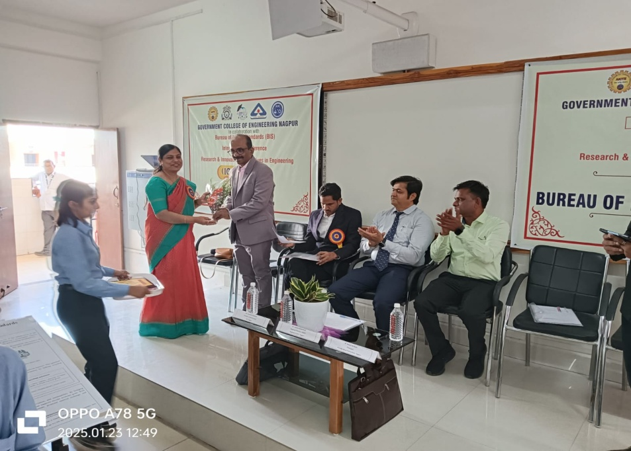

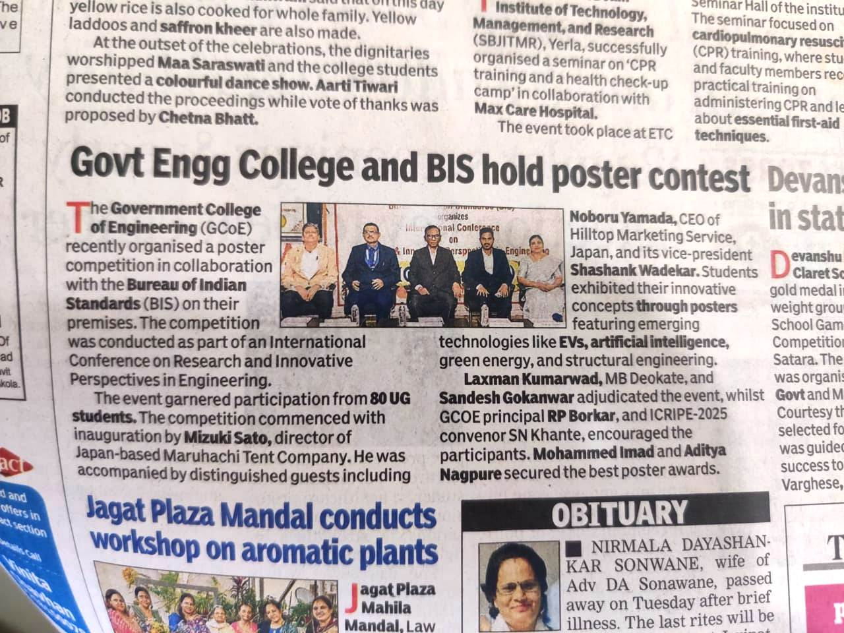

Great contribution of distinguished keynote speakers at International conference on “Research & Innovative Perspectives in Engineering” (ICRIPE-2025) held at Government College of Engineering, Nagpur
The two day International conference ICRIPE-25,organised by at Government Collegeof Engineering,Nagpur on 23 and 24th January,2025 in which distinguished keynote speakers delivered their speeches. On first day Dr Sudarshan Kurwadkar Professor of Civil and Environmental EngineeringCalifornia State University, Fullerton(USA) delivered his keynote speech on “State of the Environment: Innovative Solutions for Sustainable Water and Wastewater Management in Urban Areas” highlighting the problems of water scarcity in USA and India too.He stressed upon the technology to be adopted to address the water scarcity occurring in global areas.
Another keynote speaker was Retired professor and Technical Consultant of Headspring Inc.Tokyo (JAPAN) and his keynote speech was on “A Modern Japanese Power-Electronics Education Tool by means of RAPID”. He stressed upon the contact less charging of vehicles and innovation in power electronics.
On 2nd day Keynote Speech of Dr. Tarendra Lakhankar, Director, Education and Training Pilar, CUNY CREST Institute New York. He spoke on “Satellite Remote sensing Applications in Engineering and Educational Opportunities in USA”. He gave an insight to all possible Remote sensing applications, challenges paving way for possible Research in the field. Later Keynote Speech by Shri Sandesh Gokanwar , Scientist D/ Joint Director Bureau of IndianStandard, Govt Of India, focused on the Basic of Standards and its importance and also briefed the participants about initiatives of BIS.
All 4 keynote speakers highlighted the problems, possible solution and advances in emerging field and appeal to all faculty, students to do further research in these areas. Prof. R.P.Borkar. principal of the institute and Convener Dr. Suraj Khante thanked them for their keynote speeches in ICRIPE-2025.
Photographs of the Event

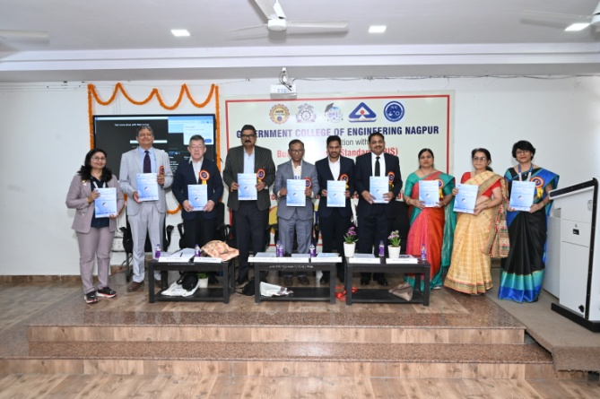 | 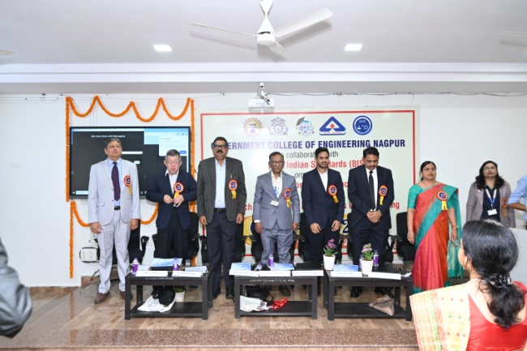
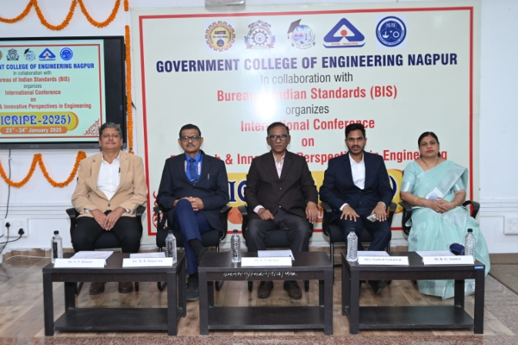 | 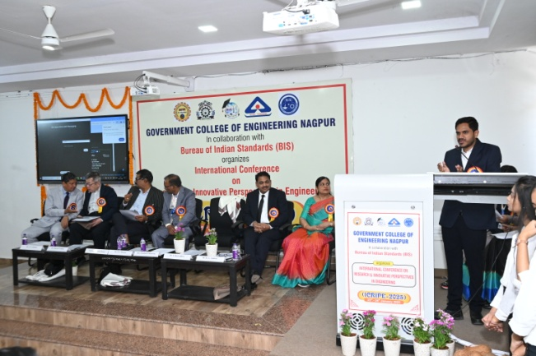
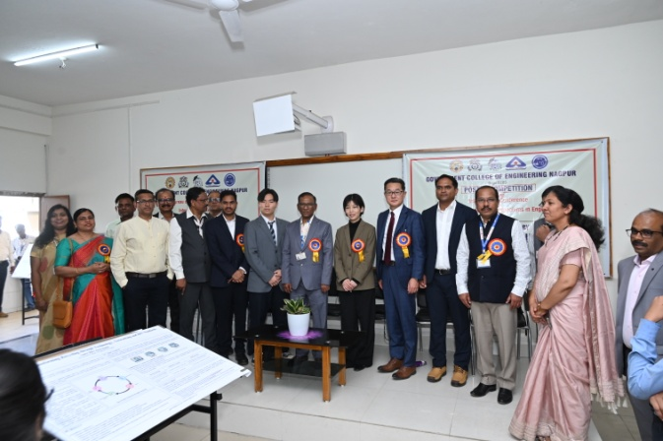 | 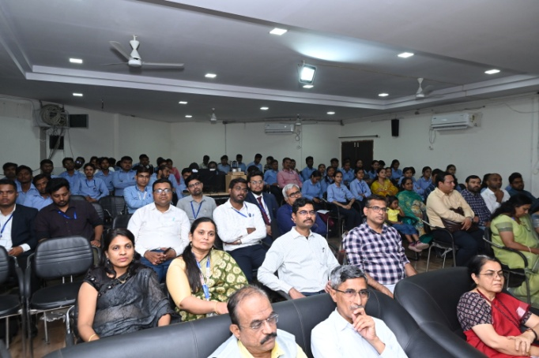
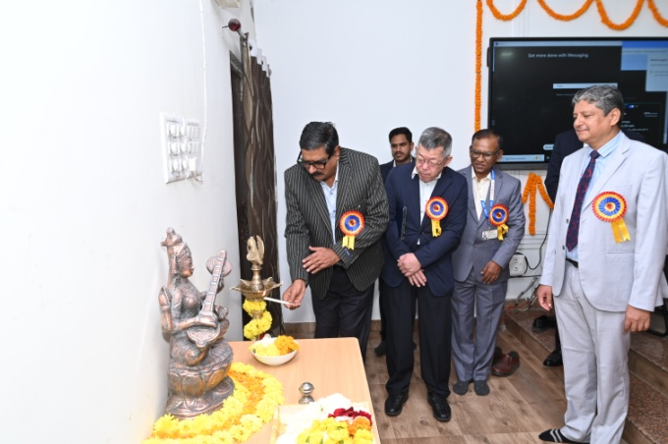 | 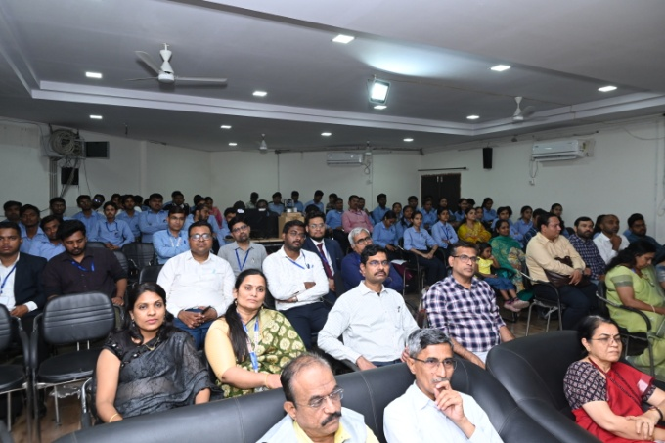
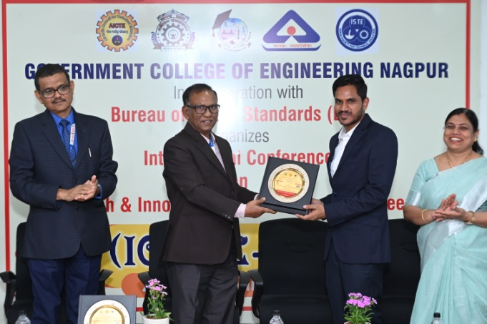 | 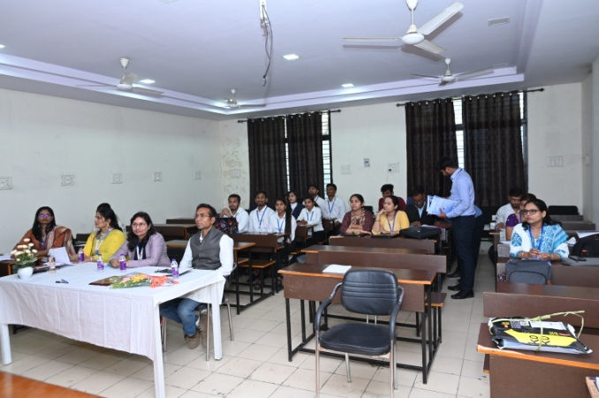
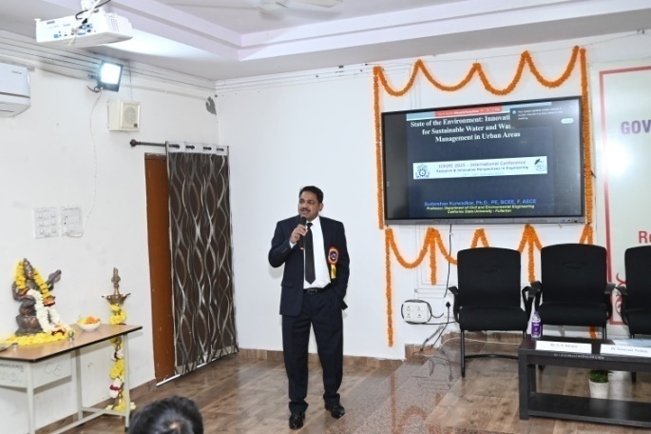 | 