HORIZON Report
EVENT – HORIZON
CONDUCTED BY – Department of electronics and telecommunication through ETSA (Electronics and telecommunication students association)
DATE – 27TH AND 28TH NOVEMBER
MODE – ONLINE
PLATFORM – GOOGLE MEET
PARTICIPANTS – 50 + Participants participated in different competitions.
INAUGURATION – The inauguration was done by the gracious hands of our respected Head of the department, Dr.Rajashree Raut ma’am who emboldened the student’s spirits. The meet was presided by the dean students GCOEN, respected DR. K. M. Tajne ma’am who appreciated the event and encouraged the students to grow through such events.
5 events were conducted in Horizon spanning different domains.
1] TALK THE TALK
Talk the talk began with the round 1 where the participants were given five topics beforehand of which they were required to speak for 3 mins on the topic of their given choice . Round 2 was a debate cum speech event and the participants were provided with topic beforehand by respected judges. They were asked to put forward their views in the form of; for the motion and against the motion and then counter each other`s viewpoints . Both the participants elucidated their chosen sides clearly and were articulate while raising arguments .
2] ABSTRACT
Abstract was the online designing competition of Horizon where participants got a chance to showcase their creative skills and bring out the inner artist in them .The topics were given well in advance to the participants and they were asked to submit their artwork in the highest resolution possible .
3] OVERLOCKED
Overlocked was a esports event. It included games such as Valorant and PUB-G. It was a huge success and attracted a good number of participants. This event was conducted in 2 rounds in which the teams battled it out to win it all.
4] LET’S GET TRIVIAL
Then a fun trivia named "Let's get trivial" was organised which was conducted in 3 rounds. Round 1 was the time based elimination round. Round 2 and 3 were both time and score based. The response and enthusiasm by the participants was very great. The teams were very competitive and it was a neck to neck competition.
5] IDEATHON
The event Ideathon was an online hackathon challenge . It was conducted to test the thinking and technical skills of students.It provided the participants a platform to showcase innovative ideas. It was nationwide competition wherein the Participants need to submit innovative ideas. The themes of the challenge were provided in advance and were based on COVID-19 pandemic.Out of the given themes the participant choose one theme in which they need to select one problem statement. In open innovation round the participants were free to implement any idea related pandemic condition. There were two categories Software and Hardware. For Software Category the participants were required to make website or app, demo video and describe idea using PPT and for Hardware Category had to send demo video of their project and describe the idea using PPT.
CONCLUSION – The event was concluded during the valedictory ceremony in which the winners of the competitions were announced by principal sir.The ceremony was graced by our alumni Mr. Rajat Motghare who guided and encouraged the students. Overall the response and fervour of the participants was great and the event was a huge success.
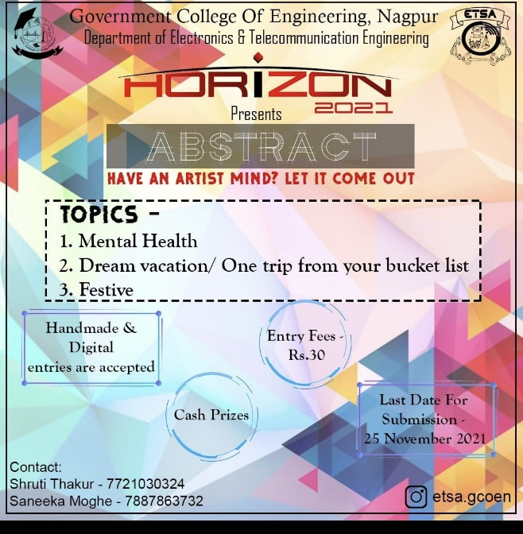
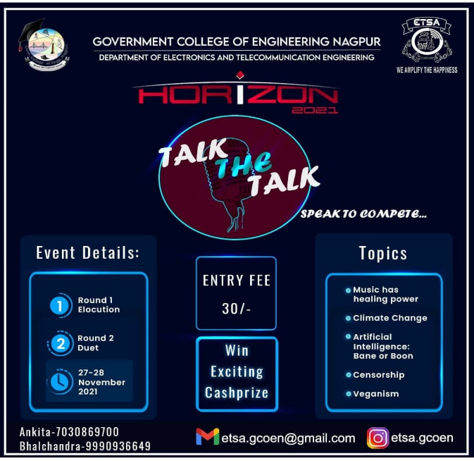
EVENT POSTERS -


