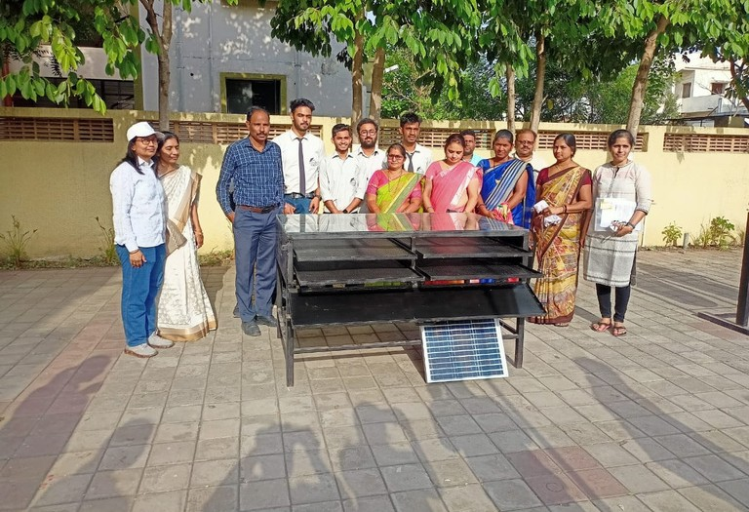24th Sept, 2022 [www.gocen.ac.in](http://www.gocen.ac.in/)

ARIIA

ATAL RANKING OF INSTITUTIONS

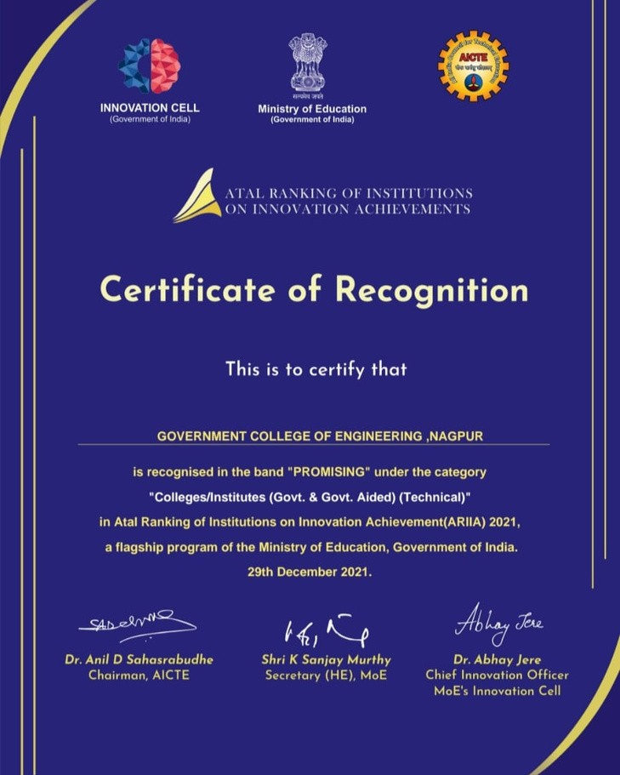OF INNOVATION ACHIEVMENTS

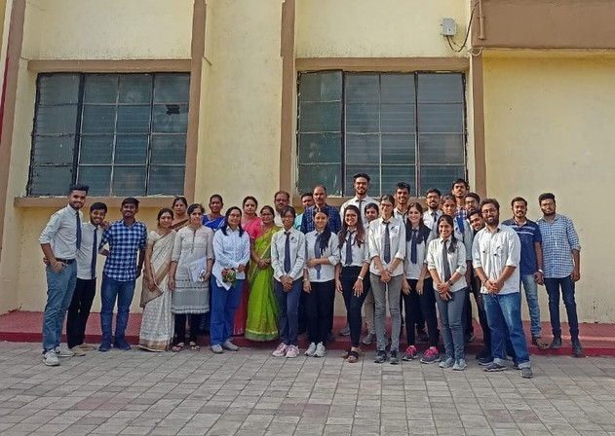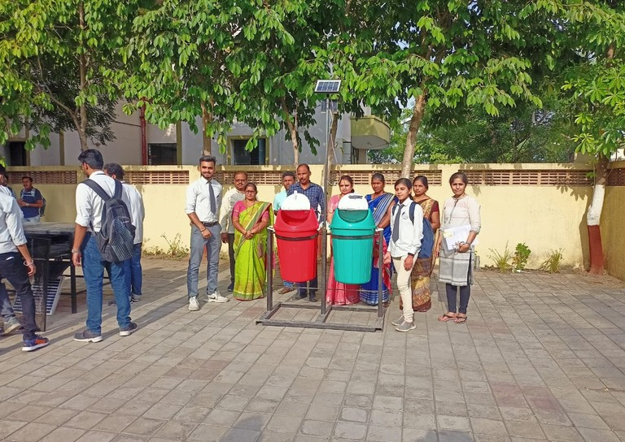

HIGLIGHT

Atal Ranking of Institutions on Innovation Achievements (ARIIA) is an initiative of Ministry of Education (MoE), Govt. of India to systematically rank all major higher educational institutions and universities in India on indicators related to “Innovation and Entrepreneurship Development” amongst students and faculties.

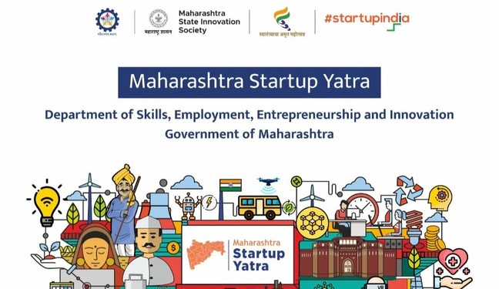

The rankings will certainly inspire Indian institutions to reorient their mind-set and build ecosystems to encourage high quality research, innovation and entrepreneurship in their campuses.